EXNO:2 Visualizing Time series Data

DATE:23.01.25

AIM: Implement programs for visualizing time series data

PROCEDURE AND CODE:

Step1:

import pandas as pd

import numpy as np

import matplotlib.pyplot as plt

import seaborn as sns

data=pd.read_csv("/content/LBMA-SILVER.csv")

Step2:

data.plot()

Step3:

import pandas as pd

import matplotlib.pyplot as plt

# Sample data

data = {

"Date": ["2022-04-21", "2022-04-20", "2022-04-19", "2022-04-14", "2022-04-13"],

"High": [24.645, 25.200, 25.915, 25.655, 25.640],

"Low": [18.87, 19.30, 19.89, 19.54, 19.72],

"Close": [22.61, 23.21, 24.01, 23.53, 23.68],}

# Convert to DataFrame

df = pd.DataFrame(data)

# Convert the 'Date' column to datetime

df['Date'] = pd.to_datetime(df['Date'])

# Set the 'Date' column as the index

df = df.set_index('Date')

# Plot the 'Close' prices

plt.figure(figsize=(10, 6))

plt.plot(df.index, df['Close'], label='Close Prices', marker='o', color='blue')

plt.title('Time Series Plot of Close Prices')

plt.xlabel('Date')

plt.ylabel('Close Price')

plt.grid()

plt.legend()

plt.show()

Step4:

# Bar Plot

plt.figure(figsize=(10, 6))

plt.bar(df.index, df['Close'], color='blue')

plt.title('Bar Plot of Close Prices')

plt.xlabel('Date')

plt.ylabel('Close Price')

plt.grid()

plt.show()

Step5:

# Histogram

plt.figure(figsize=(10, 6))

plt.hist(df['Close'], bins=5, color='blue', edgecolor='black')

plt.title('Histogram of Close Prices')

plt.xlabel('Close Price')

plt.ylabel('Frequency')

plt.grid()

plt.show()

Step6:

# Box Plot

plt.figure(figsize=(10, 6))

sns.boxplot(x=df['Close'], color='blue')

plt.title('Box Plot of Close Prices')

plt.xlabel('Close Price')

plt.grid()

plt.show()

Step7:

# Scatter Plot

plt.figure(figsize=(10, 6))

plt.scatter(df.index, df['Close'], color='blue')

plt.title('Scatter Plot of Close Prices')

plt.xlabel('Date')

plt.ylabel('Close Price')

plt.grid()

plt.show()

OUTPUTS:

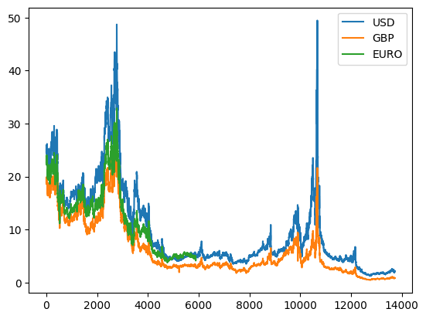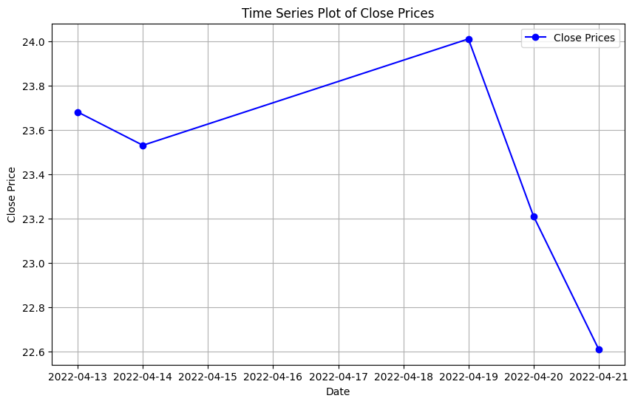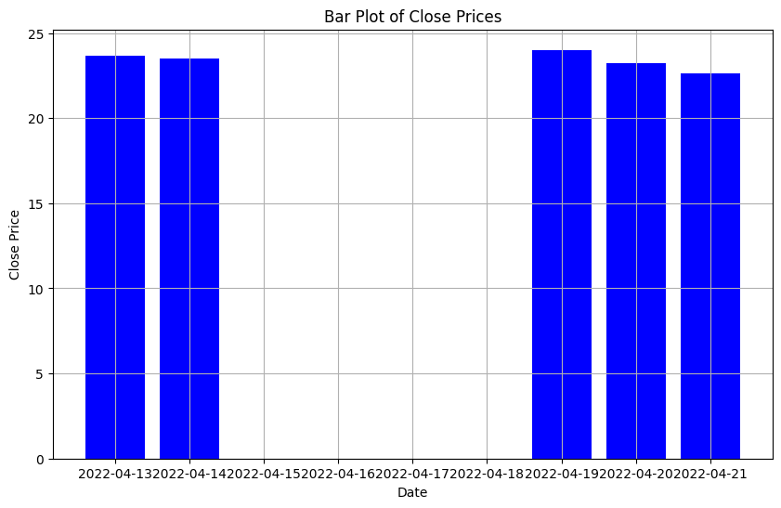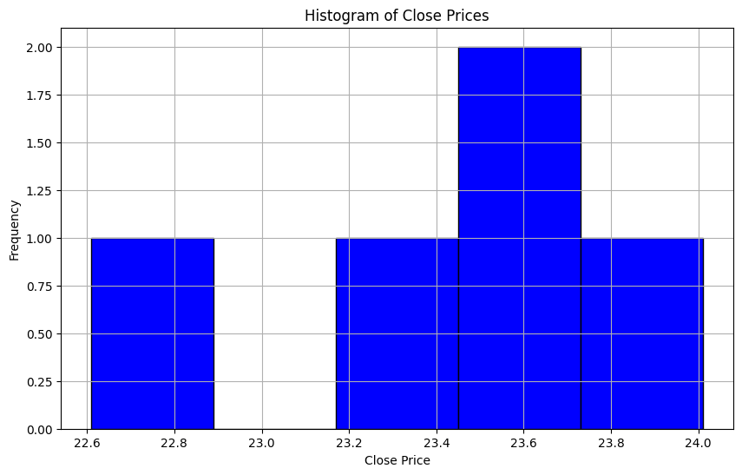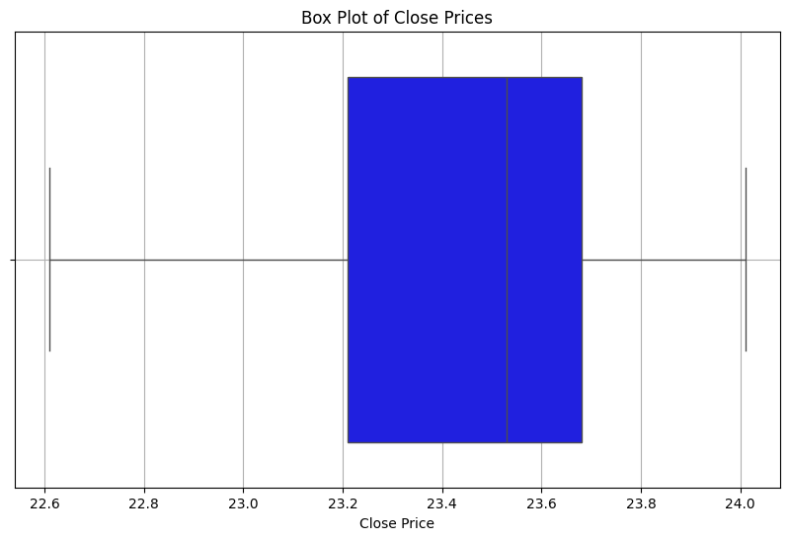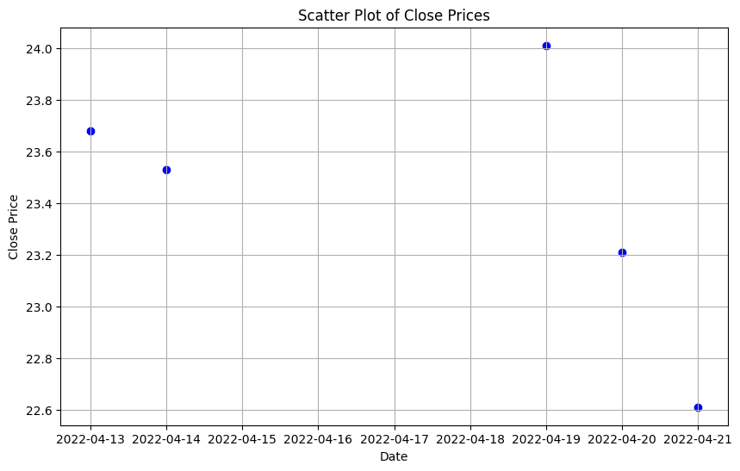

RESULTS:

Thus the program has been executed successfully